OTHER MINISTRIES THROUGH MISSIONS ALIVE

MAGIC ALIVE – Gospel magic performed worldwide. Already Harvey has been in over 42 overseas countries and 35 USA states using his talents!
PRODUCTIONS ALIVE – our 1700 footage tapes of videos and media to be transferred to DVD and streamed for usage by missionaries and churches.
YOUTH ALIVE – Programs in missions, planned and led for youth. Your church, youth groups, VBS, or camps need to take advantage of these time proven programs.
WORLD STORIES ALIVE – Harvey’s personal stories from around the world made available on video or live. The first one is entitled “Animal Stories of Africa” with Harvey speaking to a group of kids telling his stories of Africa.

- WORKSHOPS

- “How to change the church from a “Just Giving” to become a “Sending Agency”
- “Dynamic Faith Promise”
- “The Faith Walk”
- “Vitalized”
- “So Send I You”
- “Teaching with Results”
- “Making Missions Grow”
- “Wow, That’s Exciting”
- “A Mission Vision for the Local Church”
- Many more, just ask!
- SPEAKING.
- Faith Promise Rallies
Umbrella for other Missions This is explained on the inside page.

- Special Events
- Revivals that Revive
- Preaching Sunday Messages
- Sharing during Sunday School

MISSIONS ALIVE’S COMMITMENT IS TO DEVELOP STRATEGIC PARTNERSHIPS WITH MISSIONS, CHURCHES, AND INDIVIDUALS TO ACCOMPLISH
THE GREAT COMMISSION!
- Sharing World Wide Stories
- Youth Programs
- Camps
- Training programs
- VBS Missions Speaker
  - Using Artifacts
  - Costumes of Countries
  - Dynamic Stories
- Magic with a Message
Services Offered for Churches

MISSIONS ALIVE

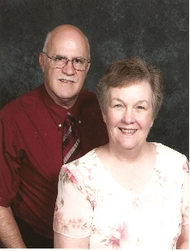

AVAILABLE FOR SPEAKING
Harvey Waddelow

.

VISION FOR THE fUTURE
Both graduates of Lincoln Christian University, Harvey and LeAnn served 13 years with African Christian Mission in Zaire (now known as the Congo). They worked to train and equip nationals throughout the region. Upon returning to America in 1981, Harvey was chosen to be the President of the National Missionary Convention (ICOM) for the 1983 convention. Harvey has been in over 40 different countries, assisting missionaries and preaching the Gospel.
Seeing the need for additional training of missionaries for overseas work, the Waddelows formed Missions Alive. Harvey and LeAnn understand the needs and difficulties of missionaries and are uniquely qualified to assist them in their ministries.

to anyone who will listen to us. They helped us reclaim over 700 square feet of our house!” - Annie

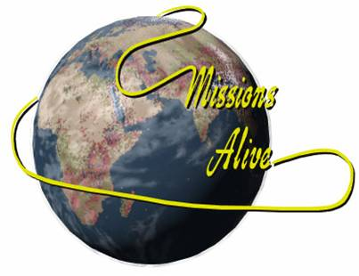
OUR SERVICES OF ASSISTANCE to MISSIONS AND CHURCHES

MISSIONS ALIVE
1927 E. 125 S.
Franklin, IN 46131
Harvey’s cell 317-902-2384
harveywaddelow@hotmail.com
www.missionsalive.org

Use our services
to assist your ministry.

OUR PARTNERSHIP MINISTRY HAS FIVE DIVISIONS OF ASSISTANCE FOR MISSIONS

SKILLED TEAMS
Contact us with your information, skills, and talents you are willing to use for the Lord when the need arises on a mission field for that area of expertise.
Your information is placed on our website and protected from view. Only your skills and talents are listed. You will be notified when requests come concerning your skills, and if you are willing at that time to assist, we will notify the one requesting. They will contact you personally after receiving your information.
Someone from Missions Alive will assist you in your preparation, CHE training, and accompany you in the project if needed.
Harvey is available to speak for churches, worldwide training, conferences, CHE training, camp missions, VBS, speaking, and encouragement. We are ready to serve your needs.

C.H.E. Training
Harvey has been certified to teach the TOT1 training course for C.H.E. (Community Health Evangelism) He is willing to assist any mission that needs help in setting up, teaching, and followup for the series. Each of our ministries for Missions Alive have incorporated the Che concept into their working and understanding for stability and giving ownership to the people.
MISSIONS ALIVE
IS CELEBRATING
36 YEARS OF SERVICE

PROJECT Assistance and Resources
Our goal is to provide assistance to those working through Missions Alive, and others, on projects requiring additional resources and representation. Each project is evaluated to the necessity and availability of Missions Alive’s personnel, time, and resources.
Missions Alive gathers information of resources, hard to get items, and places items can be purchased at a reasonable or discounted price for mission or church work.

Three missions have joined us under the umbrella of Missions Alive for their
Non-for-Profit status.

Mikes Mission to Thailand
Mike Ward, a veteran missionary of 27 years, is assisting Missions Alive during his extended leave from Thailand. He is on dialysis waiting for a replacement kidney. He needs your continued support as he eagerly waits to return to Thailand with his family.
Mike’s cell 765-343-3022
Myanmar Christian Services
Steve Ward, of Myanmar Christian Services. Steve’s desire is to help the orphans and ministers in that area through projects, like building a pipeline over the mountain to get water for the orphanage and leading work teams to the country. Steve’s cell 317-640-0536
Davao City Outreach

PREVENTION Assistance
Missions Alive, along with many others, are seeking answers to hunger and jobs for Christians worldwide. We are studying ways used by others and researching new ways that will work. We are researching ways to share that information to many areas.
We do not have the answers, but in the future by using video we can share research center findings with others who cannot get that information. We will utilize organizations already developed to fight hunger and provide jobs.

OTHER Assistance Offered
Several training seminars are available to enhance ministries such as TEE, fund raising, visibility, utilizing native culture and solutions are offered within these courses.
John and Gina Allcott of Davao City Outreach are meeting needs and caring for the poor especially after the recent earthquakes and floods. They are preparing laborers for the Harvest fields locally and abroad to reach the unreached tribes, both in their churches and local seminaries, and para-church organizations . They have already planted 2 churches and are working in other areas.
Also, we teach the effectiveness of the tropical tree called Maringa (the miracle tree) for feeding the hungry with everything the body needs for a complete day. The tree also purifies water, the great need of the world. Contact us for additional information how it can help your health also.

